INFO B-581 SPRING 2024

PROJECT SPRINT 4
GROUP 5
THE SAVVY HEALTH SQUAD
Deepishka Pemmasani
Harika Mareddy
Meghana Darla
Priyankitha Kandi

Department of BioHealth Informatics
Luddy School of Informatics, Computing, and Engineering
IUPUI
Dr. Saptarshi Purkayastha
April 20, 2024

Step 1: System A and System B:
- System A: Electronic Health Record (EHR) system (OpenMRS)
- Interchange format: XML (CCDA)
- Rationale:
OpenMRS is an open-source electronic medical record system notable for its modular architecture, allowing for extensive customization and new functionalities without altering the core system. It supports the secure management of electronic patient records, including medical histories and treatment plans, and offers interoperability with other health information systems for seamless data exchange. Additionally, OpenMRS features user and patient management, appointment scheduling, laboratory and pharmacy management, and robust reporting tools. It is adaptable to various languages and cultural contexts, supported by a global community that aids in its continuous development.
In this use case, OpenMRS serves as the primary system used by the clinician to document the patient's diagnosis of hypertensive urgency, prescribe the appropriate medication (clonidine), and provide instructions for monitoring the patient's blood pressure.

- System B: Nursing documentation system (OpenELIS)
- Interchange format: JSON
- Rationale:
OpenELIS is an open-source laboratory information system (LIS) that is designed to manage and streamline laboratory operations (Mamlin et al., 2006). It focuses on supporting the workflow of laboratory processes, including test ordering, sample management, result entry, and reporting.
In the given use case, OpenELIS is used as the system for capturing and managing laboratory-related data.

Interoperability between System A and System B:

To achieve interoperability, the CDA document is transformed using XSLT (Extensible Stylesheet Language Transformations) to extract relevant sections such as patient information, encounters, vital signs, plan of treatment, and consultation notes. The XSLT stylesheets are designed to map and convert the CDA data into a format compatible with OpenELIS, typically JSON (JavaScript Object Notation) (Wolfe et al., 2006).
The transformed data is then transmitted from OpenMRS to OpenELIS using standardized protocols and APIs (Application Programming Interfaces). OpenELIS receives the patient and laboratory-related information, such as test orders and results, and seamlessly integrates it into its own data structure (Mamlin et al., 2006). This integration allows OpenELIS to effectively manage and process the laboratory data within its specialized laboratory information system.
Conversely, when laboratory results are available in OpenELIS, the system transforms the data into a format compatible with OpenMRS, typically using JSON. The transformed data is then sent back to OpenMRS via APIs, where it is integrated into the patient's electronic health record (Tierney et al., 2010). This bidirectional flow of information ensures that healthcare providers have access to up-to-date laboratory results within the OpenMRS system, facilitating informed decision-making and improved patient care.
The use of standardized data formats, such as HL7 and FHIR, along with the implementation of XSLT transformations and API-based communication, enables seamless interoperability between OpenMRS and OpenELIS. This interoperability streamlines the ordering, processing, and reviewing of laboratory tests, reduces manual data entry, and enhances the efficiency of healthcare delivery in the given use case (Benson & Grieve, 2016).

Step 2: Relevant sections from the CCDA document for the nursing documentation system:
- Patient Information:

Patient Information is fundamental to any healthcare interaction and forms the cornerstone of the interoperability between different systems. This section includes critical identifiers such as name, date of birth, patient ID, and other demographic details.

It is necessary for identifying the patient in the nursing documentation system.

Adding this section ensures that both our sender and receiver systems are referring to the same individual, thus preventing any potential errors in patient care that could arise from mismatched records. This is crucial in environments where multiple patients might have similar names or other identifying details.

- Encounters –

Encounters provide a detailed log of each interaction the patient has with healthcare providers, including visits for consultations, treatments, or emergency interventions.

This section helps to track the sequence of events in a patient’s healthcare journey, providing context for interpreting laboratory results and other clinical data.

It provides context about the patient's visit and the associated diagnosis.

- Vital Signs –

Vital signs are critical clinical measurements such as blood pressure, heart rate, respiratory rate, and temperature, which provide immediate insights into a patient's health status.

This is required for monitoring the patient's blood pressure as per the clinician's instructions.

This section is vital for monitoring critical aspects of a patient's health, especially in conditions like hypertensive urgency where blood pressure readings are crucial for immediate clinical decisions.

- Plan of Treatment –

This section details the prescribed medical interventions, medications, therapy plans, and monitoring schedules devised by the healthcare provider. This information helps nursing staff to administer treatments correctly and prompts laboratory technicians to prioritize certain tests.

In our case, it includes the prescribed medication and the instructions for periodic blood pressure monitoring, which the nurse needs to follow and document.

- Consultation notes –

Consultation notes contain narrative description from the clinician detailing assessments, clinical reasoning, diagnoses, and specific patient care instructions.

In our case, the consultation notes section provides critical information about the patient's clinical assessment, diagnosis, treatment plan, and monitoring instructions, which is essential for the nursing staff to deliver comprehensive and coordinated care.

Step 3: XSLT stylesheets for extracting the required sections:
- Patient Information (patient_info.xslt):
<?xml version="1.0" encoding="UTF-8"?>
<xsl:stylesheet version="1.0" xmlns:xsl="http://www.w3.org/1999/XSL/Transform"
xmlns:cda="urn:hl7-org:v3" xmlns:sdtc="urn:hl7-org:sdtc">
<xsl:output method="text" indent="yes"/>

<xsl:template match="/">
{
"planOfTreatment": [
<xsl:for-each select="//cda:section[cda:templateId/@root='2.16.840.1.113883.10.20.22.2.10']/cda:entry/cda:procedure">
{
"id": "<xsl:value-of select="cda:id/@root"/>",
"code": {
"code": "<xsl:value-of select="cda:code/@code"/>",
"displayName": "<xsl:value-of select="cda:code/@displayName"/>",
"codeSystem": "<xsl:value-of select="cda:code/@codeSystem"/>",
"codeSystemName": "<xsl:value-of select="cda:code/@codeSystemName"/>"
},
"statusCode": "<xsl:value-of select="cda:statusCode/@code"/>",
"effectiveTime": "<xsl:value-of select="cda:effectiveTime/@value"/>",
"author": {
"time": "<xsl:value-of select="cda:author/cda:time/@value"/>",
"assignedAuthor": {
"id": "<xsl:value-of select="cda:author/cda:assignedAuthor/cda:id/@extension"/>",
"code": {
"code": "<xsl:value-of select="cda:author/cda:assignedAuthor/cda:code/@code"/>",
"displayName": "<xsl:value-of select="cda:author/cda:assignedAuthor/cda:code/@displayName"/>",
"codeSystem": "<xsl:value-of select="cda:author/cda:assignedAuthor/cda:code/@codeSystem"/>",
"codeSystemName": "<xsl:value-of select="cda:author/cda:assignedAuthor/cda:code/@codeSystemName"/>"
}
}
},
"plannedCoverage": [
<xsl:for-each select="cda:entryRelationship/cda:act[cda:templateId/@root='2.16.840.1.113883.10.20.22.4.129']/cda:entryRelationship/cda:act">
{
"id": "<xsl:value-of select="cda:id/@root"/>",
"code": "<xsl:value-of select="cda:code/@code"/>",
"displayName": "<xsl:value-of select="cda:code/@displayName"/>",
"codeSystemName": "<xsl:value-of select="cda:code/@codeSystemName"/>",
"statusCode": "<xsl:value-of select="cda:statusCode/@code"/>"
}<xsl:if test="position() != last()">,</xsl:if>
</xsl:for-each>
],
"patientPriorityPreference": {
"effectiveTime": "<xsl:value-of select="cda:entryRelationship/cda:observation[cda:templateId/@root='2.16.840.1.113883.10.20.22.4.143'][1]/cda:effectiveTime/@value"/>",
"code": "<xsl:value-of select="cda:entryRelationship/cda:observation[cda:templateId/@root='2.16.840.1.113883.10.20.22.4.143'][1]/cda:priorityCode/@code"/>",
"displayName": "<xsl:value-of select="cda:entryRelationship/cda:observation[cda:templateId/@root='2.16.840.1.113883.10.20.22.4.143'][1]/cda:priorityCode/@displayName"/>",
"value": "<xsl:value-of select="cda:entryRelationship/cda:observation[cda:templateId/@root='2.16.840.1.113883.10.20.22.4.143'][1]/cda:value/@code"/>"
},
"priorityPreference": {
"effectiveTime": "<xsl:value-of select="cda:entryRelationship/cda:observation[cda:templateId/@root='2.16.840.1.113883.10.20.22.4.143'][2]/cda:effectiveTime/@value"/>",
"code": "<xsl:value-of select="cda:entryRelationship/cda:observation[cda:templateId/@root='2.16.840.1.113883.10.20.22.4.143'][2]/cda:code/@code"/>",
"displayName": "<xsl:value-of select="cda:entryRelationship/cda:observation[cda:templateId/@root='2.16.840.1.113883.10.20.22.4.143'][2]/cda:code/@displayName"/>",
"value": "<xsl:value-of select="cda:entryRelationship/cda:observation[cda:templateId/@root='2.16.840.1.113883.10.20.22.4.143'][2]/cda:value/@code"/>"
}
}<xsl:if test="position() != last()">,</xsl:if>
</xsl:for-each>
]
}
</xsl:template>

</xsl:stylesheet>

- Encounters (encounters.xslt):
<?xml version="1.0" encoding="UTF-8"?>
<xsl:stylesheet version="1.0" xmlns:xsl="http://www.w3.org/1999/XSL/Transform"
xmlns:cda="urn:hl7-org:v3" xmlns:sdtc="urn:hl7-org:sdtc">
<xsl:output method="text" indent="yes"/>

<xsl:template match="/">
{
"encounters": [
<xsl:for-each select="//cda:section[cda:templateId/@root='2.16.840.1.113883.10.20.22.2.22.1']/cda:entry/cda:encounter">
{
"id": "<xsl:value-of select="cda:id/@root"/>",
"code": {
"code": "<xsl:value-of select="cda:code/@code"/>",
"displayName": "<xsl:value-of select="cda:code/@displayName"/>",
"codeSystem": "<xsl:value-of select="cda:code/@codeSystem"/>",
"codeSystemName": "<xsl:value-of select="cda:code/@codeSystemName"/>"
},
"effectiveTime": "<xsl:value-of select="cda:effectiveTime/@value"/>",
"performer": [
<xsl:for-each select="cda:performer/cda:assignedEntity">
{
"id": "<xsl:value-of select="cda:id/@extension"/>",
"code": {
"code": "<xsl:value-of select="cda:code/@code"/>",
"displayName": "<xsl:value-of select="cda:code/@displayName"/>",
"codeSystem": "<xsl:value-of select="cda:code/@codeSystem"/>",
"codeSystemName": "<xsl:value-of select="cda:code/@codeSystemName"/>"
}
}<xsl:if test="position() != last()">,</xsl:if>
</xsl:for-each>
],
"participant": [
<xsl:for-each select="cda:participant[@typeCode='LOC']/cda:participantRole">
{
"code": {
"code": "<xsl:value-of select="cda:code/@code"/>",
"displayName": "<xsl:value-of select="cda:code/@displayName"/>",
"codeSystem": "<xsl:value-of select="cda:code/@codeSystem"/>",
"codeSystemName": "<xsl:value-of select="cda:code/@codeSystemName"/>"
},
"addr": {
"streetAddressLine": "<xsl:value-of select="cda:addr/cda:streetAddressLine"/>",
"city": "<xsl:value-of select="cda:addr/cda:city"/>",
"state": "<xsl:value-of select="cda:addr/cda:state"/>",
"postalCode": "<xsl:value-of select="cda:addr/cda:postalCode"/>"
},
"telecom": "<xsl:value-of select="cda:telecom/@value"/>",
"playingEntity": {
"name": "<xsl:value-of select="cda:playingEntity/cda:name"/>"
}
}<xsl:if test="position() != last()">,</xsl:if>
</xsl:for-each>
],
"entryRelationship": [
<xsl:for-each select="cda:entryRelationship/cda:act">
{
"code": {
"code": "<xsl:value-of select="cda:code/@code"/>",
"displayName": "<xsl:value-of select="cda:code/@displayName"/>",
"codeSystem": "<xsl:value-of select="cda:code/@codeSystem"/>",
"codeSystemName": "<xsl:value-of select="cda:code/@codeSystemName"/>"
},
"observation": {
"code": {
"code": "<xsl:value-of select="cda:entryRelationship/cda:observation/cda:code/@code"/>",
"displayName": "<xsl:value-of select="cda:entryRelationship/cda:observation/cda:code/@displayName"/>",
"codeSystem": "<xsl:value-of select="cda:entryRelationship/cda:observation/cda:code/@codeSystem"/>",
"codeSystemName": "<xsl:value-of select="cda:entryRelationship/cda:observation/cda:code/@codeSystemName"/>"
},
"value": {
"code": "<xsl:value-of select="cda:entryRelationship/cda:observation/cda:value/@code"/>",
"displayName": "<xsl:value-of select="cda:entryRelationship/cda:observation/cda:value/@displayName"/>",
"codeSystem": "<xsl:value-of select="cda:entryRelationship/cda:observation/cda:value/@codeSystem"/>"
}
}
}<xsl:if test="position() != last()">,</xsl:if>
</xsl:for-each>
]
}<xsl:if test="position() != last()">,</xsl:if>
</xsl:for-each>
]
}
</xsl:template>

</xsl:stylesheet>

- Vital Signs (vital_signs.xslt):
<?xml version="1.0" encoding="UTF-8"?>
<xsl:stylesheet version="1.0" xmlns:xsl="http://www.w3.org/1999/XSL/Transform"
xmlns:cda="urn:hl7-org:v3" xmlns:sdtc="urn:hl7-org:sdtc">
<xsl:output method="text" indent="yes"/>

<xsl:template match="/">
{
"vitalSigns": [
<xsl:for-each select="//cda:section[cda:templateId/@root='2.16.840.1.113883.10.20.22.2.4.1']/cda:entry/cda:organizer/cda:component/cda:observation">
{
"id": "<xsl:value-of select="cda:id/@root"/>",
"code": {
"code": "<xsl:value-of select="cda:code/@code"/>",
"displayName": "<xsl:value-of select="cda:code/@displayName"/>",
"codeSystem": "<xsl:value-of select="cda:code/@codeSystem"/>",
"codeSystemName": "<xsl:value-of select="cda:code/@codeSystemName"/>"
},
"statusCode": "<xsl:value-of select="cda:statusCode/@code"/>",
"effectiveTime": "<xsl:value-of select="cda:effectiveTime/@value"/>",
"value": {
"value": "<xsl:value-of select="cda:value/@value"/>",
"unit": "<xsl:value-of select="cda:value/@unit"/>"
}
}<xsl:if test="position() != last()">,</xsl:if>
</xsl:for-each>
]
}
</xsl:template>

</xsl:stylesheet>

- Plan of Treatment (plan_of_treatment.xslt):
<?xml version="1.0" encoding="UTF-8"?>
<xsl:stylesheet version="1.0" xmlns:xsl="http://www.w3.org/1999/XSL/Transform"
xmlns:cda="urn:hl7-org:v3" xmlns:sdtc="urn:hl7-org:sdtc">
<xsl:output method="text" indent="yes"/>

<xsl:template match="/">
{
"patient": {
"name": {
"given": "<xsl:value-of select="//cda:patient/cda:name[1]/cda:given"/>",
"family": "<xsl:value-of select="//cda:patient/cda:name[1]/cda:family"/>"
},
"gender": "<xsl:value-of select="//cda:patient/cda:administrativeGenderCode/@displayName"/>",
"birthDate": "<xsl:value-of select="//cda:patient/cda:birthTime/@value"/>",
"maritalStatus": "<xsl:value-of select="//cda:patient/cda:maritalStatusCode/@displayName"/>",
"race": "<xsl:value-of select="//cda:patient/cda:raceCode/@displayName"/>",
"ethnicity": "<xsl:value-of select="//cda:patient/cda:ethnicGroupCode/@displayName"/>",
"address": {
"street": "<xsl:value-of select="//cda:patient/cda:addr/cda:streetAddressLine"/>",
"city": "<xsl:value-of select="//cda:patient/cda:addr/cda:city"/>",
"state": "<xsl:value-of select="//cda:patient/cda:addr/cda:state"/>",
"postalCode": "<xsl:value-of select="//cda:patient/cda:addr/cda:postalCode"/>",
"country": "<xsl:value-of select="//cda:patient/cda:addr/cda:country"/>"
},
"telecom": "<xsl:value-of select="//cda:patient/cda:telecom/@value"/>",
"languageCommunication": {
"language": "<xsl:value-of select="//cda:patient/cda:languageCommunication/cda:languageCode/@code"/>",
"modeCode": "<xsl:value-of select="//cda:patient/cda:languageCommunication/cda:modeCode/@displayName"/>",
"proficiencyLevelCode": "<xsl:value-of select="//cda:patient/cda:languageCommunication/cda:proficiencyLevelCode/@displayName"/>",
"preferenceInd": "<xsl:value-of select="//cda:patient/cda:languageCommunication/cda:preferenceInd/@value"/>"
}
}
}
</xsl:template>

</xsl:stylesheet>

- Consultation notes (Consultation_notes.xslt)

<?xml version="1.0" encoding="UTF-8"?>
<xsl:stylesheet version="1.0" xmlns:xsl="http://www.w3.org/1999/XSL/Transform"
xmlns:cda="urn:hl7-org:v3" xmlns:sdtc="urn:hl7-org:sdtc">
<xsl:output method="text" indent="yes"/>

<xsl:template match="/">
{
"consultationNotes": [
<xsl:for-each select="//cda:section[cda:templateId/@root='2.16.840.1.113883.10.20.22.2.65']/cda:entry/cda:act">
{
"id": "<xsl:value-of select="cda:id/@root"/>",
"code": {
"code": "<xsl:value-of select="cda:code/@code"/>",
"displayName": "<xsl:value-of select="cda:code/@displayName"/>",
"codeSystem": "<xsl:value-of select="cda:code/@codeSystem"/>",
"codeSystemName": "<xsl:value-of select="cda:code/@codeSystemName"/>"
},
"statusCode": "<xsl:value-of select="cda:statusCode/@code"/>",
"effectiveTime": "<xsl:value-of select="cda:effectiveTime/@value"/>",
"author": {
"time": "<xsl:value-of select="cda:author/cda:time/@value"/>",
"assignedAuthor": {
"id": "<xsl:value-of select="cda:author/cda:assignedAuthor/cda:id/@root"/>",
"assignedPerson": {
"name": {
"prefix": "<xsl:value-of select="cda:author/cda:assignedAuthor/cda:assignedPerson/cda:name/cda:prefix"/>",
"given": "<xsl:value-of select="cda:author/cda:assignedAuthor/cda:assignedPerson/cda:name/cda:given"/>",
"family": "<xsl:value-of select="cda:author/cda:assignedAuthor/cda:assignedPerson/cda:name/cda:family"/>"
}
}
}
},
"text": {
"reference": "<xsl:value-of select="cda:text/cda:reference/@value"/>"
}
}<xsl:if test="position() != last()">,</xsl:if>
</xsl:for-each>
]
}
</xsl:template>

</xsl:stylesheet>

Step 4: Test the XSLT stylesheets against the CCDA document to generate the required sections.
- Patient Information 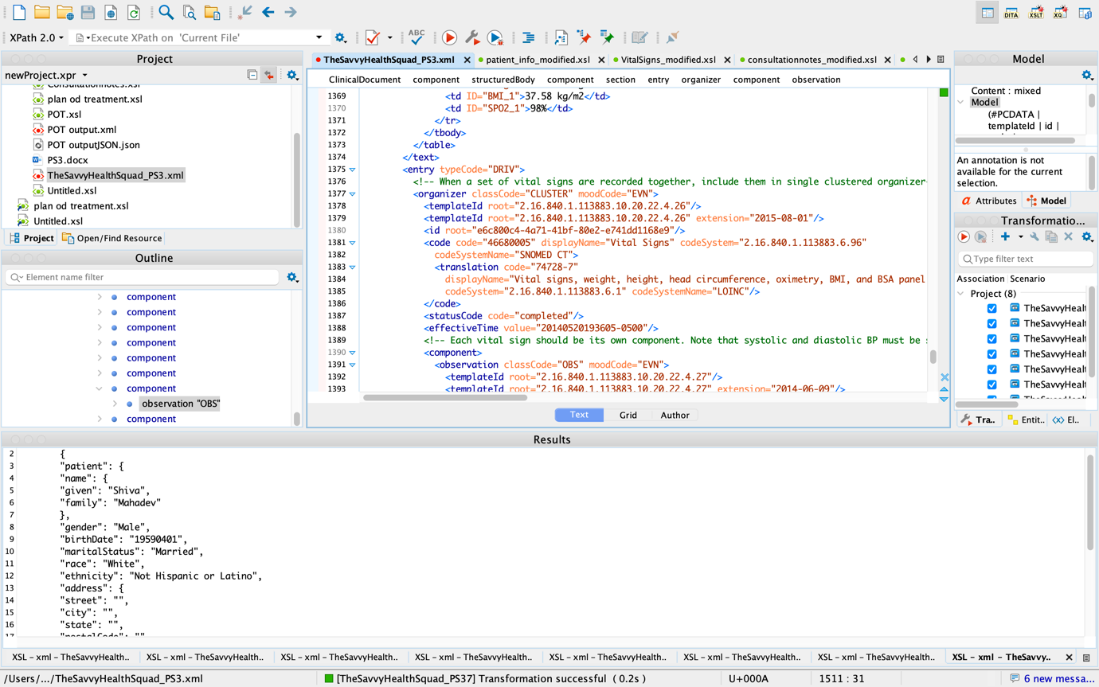

- Vital signs: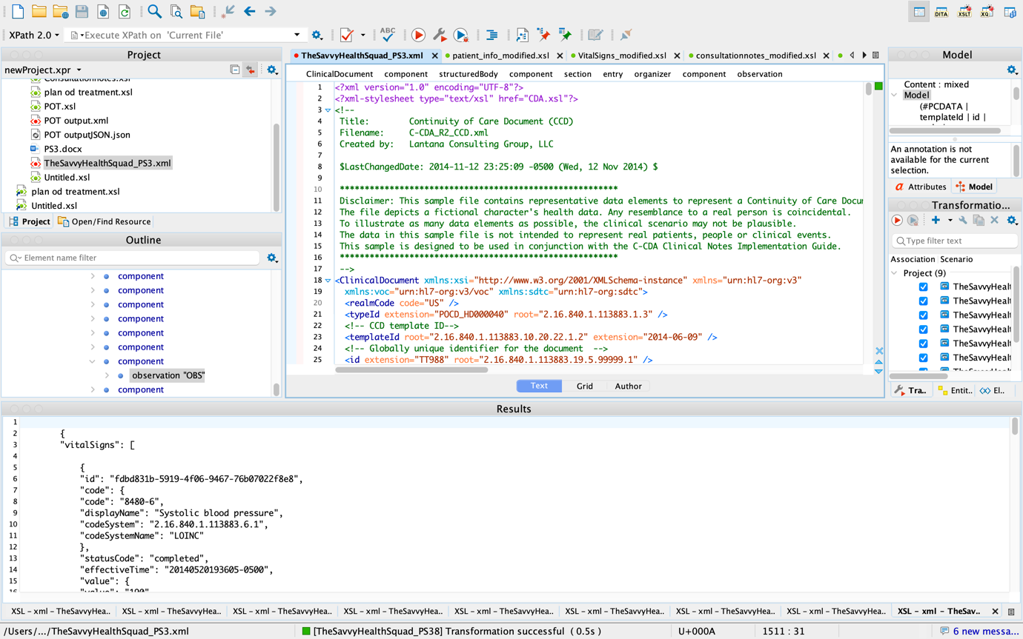

- Consultation notes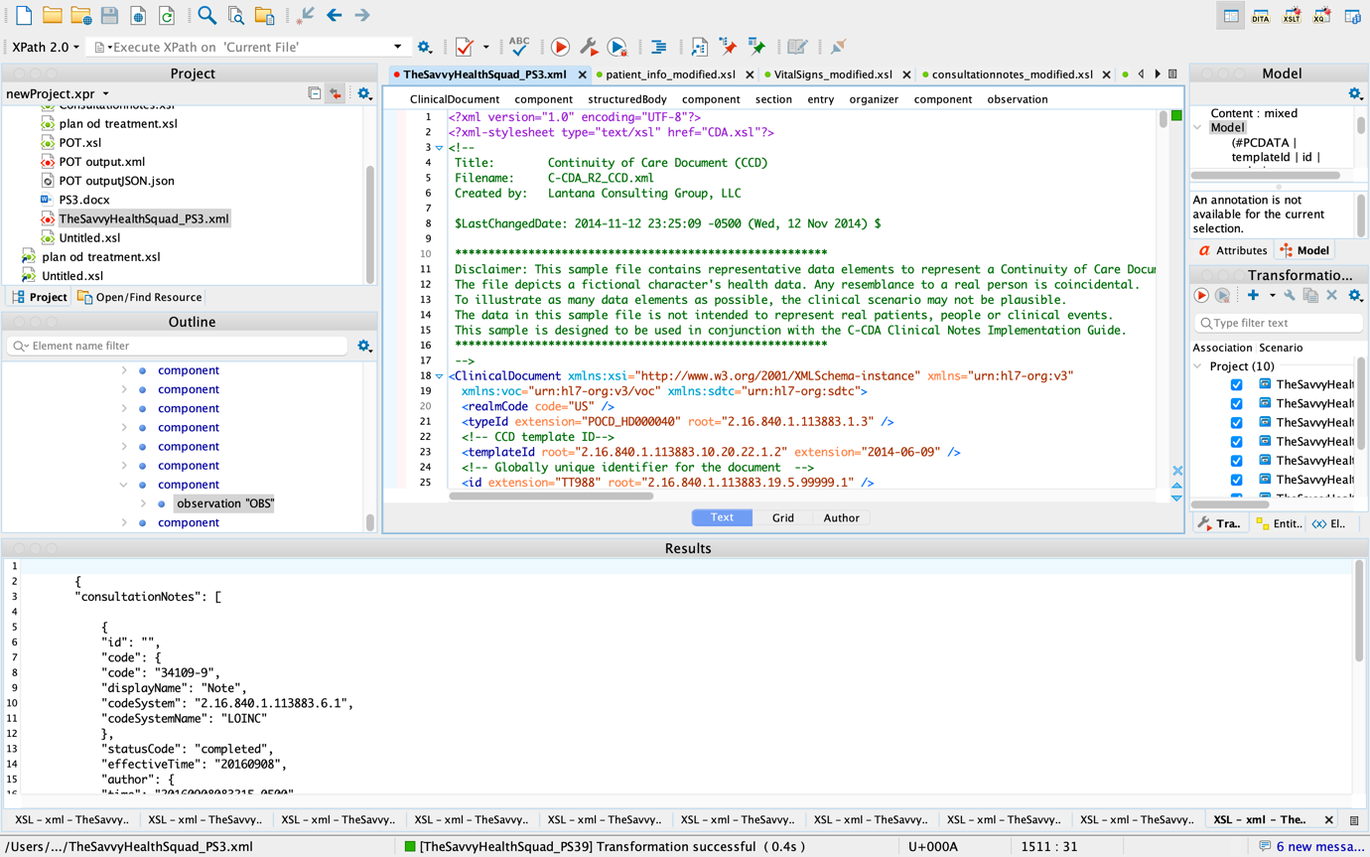
- Plan of treatment: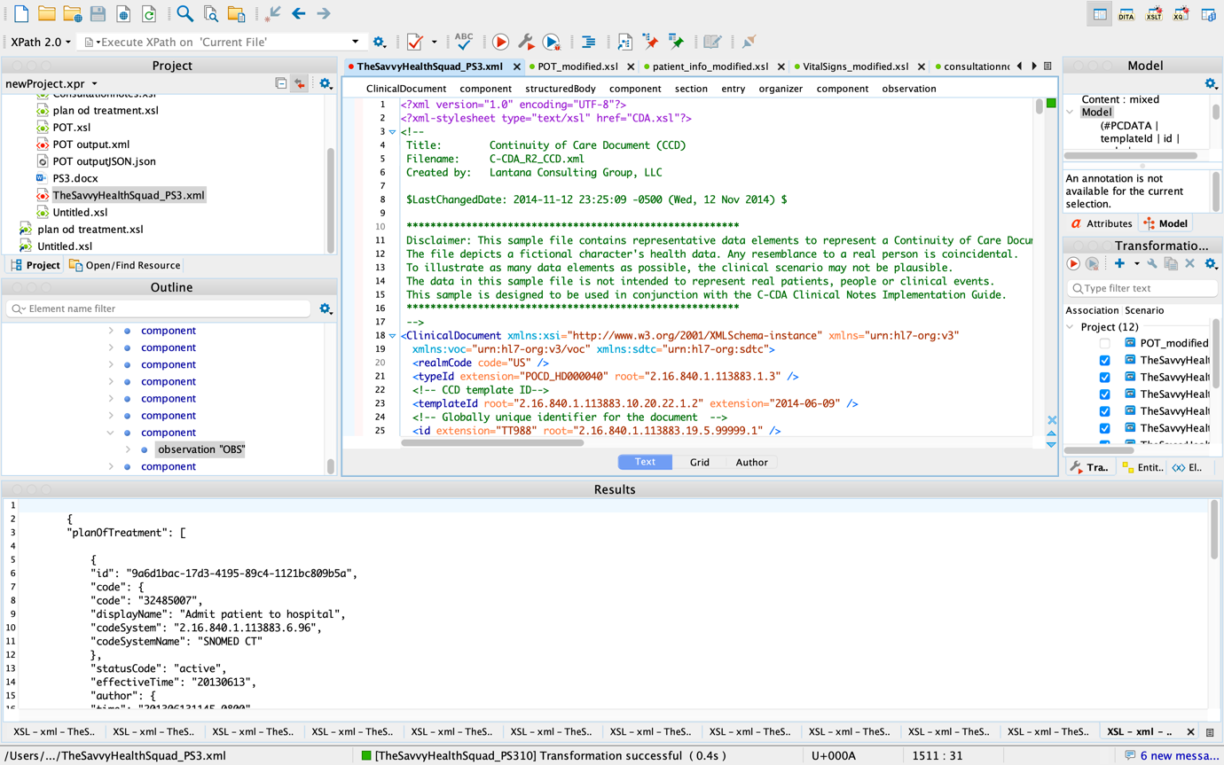

- Encounter:
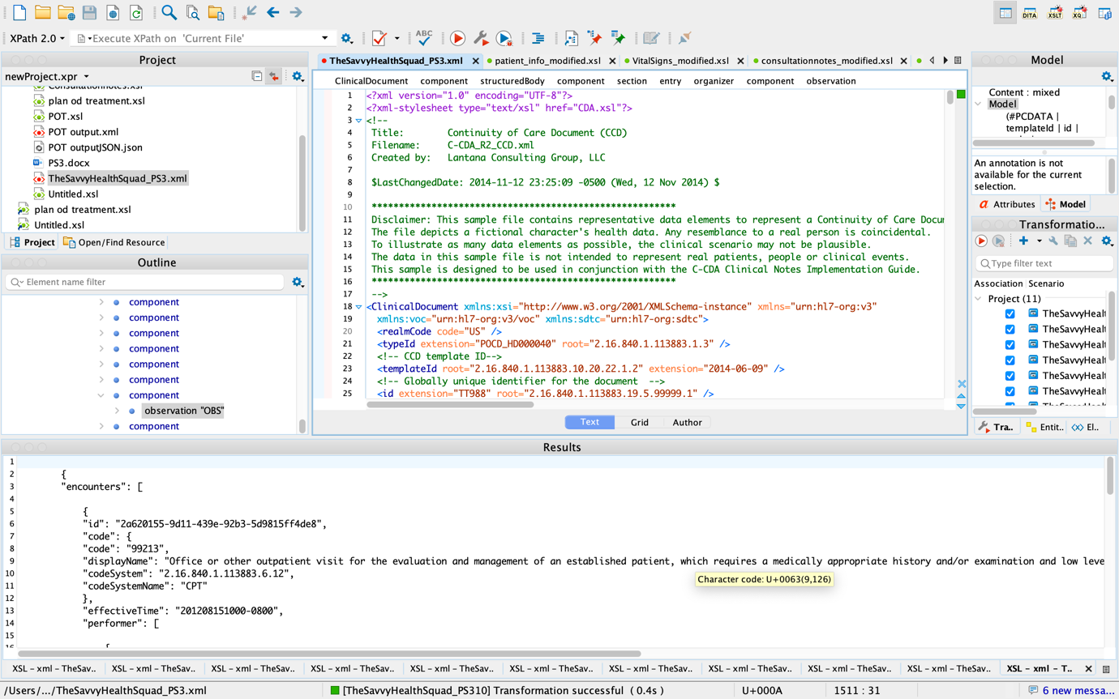

- Patient Information JSON output:

{
"patient": {
"name": {
"given": "Shiva",
"family": "Mahadev"
},
"gender": "Male",
"birthDate": "19590401",
"maritalStatus": "Married",
"race": "White",
"ethnicity": "Not Hispanic or Latino",
"address": {
"street": "",
"city": "",
"state": "",
"postalCode": "",
"country": ""
},
"telecom": "",
"languageCommunication": {
"language": "en",
"modeCode": "Expressed spoken",
"proficiencyLevelCode": "Good",
"preferenceInd": "true"
}
}
}

- Vital signs JSON output:

{
"vitalSigns": [

{
"id": "fdbd831b-5919-4f06-9467-76b07022f8e8",
"code": {
"code": "8480-6",
"displayName": "Systolic blood pressure",
"codeSystem": "2.16.840.1.113883.6.1",
"codeSystemName": "LOINC"
},
"statusCode": "completed",
"effectiveTime": "20140520193605-0500",
"value": {
"value": "190",
"unit": "mm[Hg]"
}
},
{
"id": "553f3f45-9046-4659-b3e7-5de904003550",
"code": {
"code": "8462-4",
"displayName": "Diastolic blood pressure",
"codeSystem": "2.16.840.1.113883.6.1",
"codeSystemName": "LOINC"
},
"statusCode": "completed",
"effectiveTime": "20140520193605-0500",
"value": {
"value": "130",
"unit": "mm[Hg]"
}
},
{
"id": "77bfe276-a1dd-4372-9072-e603905acc07",
"code": {
"code": "8867-4",
"displayName": "Heart rate",
"codeSystem": "2.16.840.1.113883.6.1",
"codeSystemName": "LOINC"
},
"statusCode": "completed",
"effectiveTime": "20140520193605-0500",
"value": {
"value": "80",
"unit": "/min"
}
},
{
"id": "24faa204-db62-4610-864f-cb50b650d0fa",
"code": {
"code": "8310-5",
"displayName": "Body temperature",
"codeSystem": "2.16.840.1.113883.6.1",
"codeSystemName": "LOINC"
},
"statusCode": "completed",
"effectiveTime": "20140520193605-0500",
"value": {
"value": "37.2",
"unit": "Cel"
}
},
{
"id": "79f25395-8ec6-488b-8c05-becc97f79995",
"code": {
"code": "9279-1",
"displayName": "Respiratory rate",
"codeSystem": "2.16.840.1.113883.6.1",
"codeSystemName": "LOINC"
},
"statusCode": "completed",
"effectiveTime": "20140520193605-0500",
"value": {
"value": "18",
"unit": "/min"
}
},
{
"id": "6d3fa9f8-6049-41bd-b0c3-b0196bb6bd37",
"code": {
"code": "8302-2",
"displayName": "Body height",
"codeSystem": "2.16.840.1.113883.6.1",
"codeSystemName": "LOINC"
},
"statusCode": "completed",
"effectiveTime": "20140520193605-0500",
"value": {
"value": "170.2",
"unit": "cm"
}
},
{
"id": "2594e631-2189-4e72-9dd1-d6769ee2a7be",
"code": {
"code": "29463-7",
"displayName": "Body weight",
"codeSystem": "2.16.840.1.113883.6.1",
"codeSystemName": "LOINC"
},
"statusCode": "completed",
"effectiveTime": "20140520193605-0500",
"value": {
"value": "88",
"unit": "kg"
}
},
{
"id": "5858e765-2ffe-413f-9197-260f2c6e7aa8",
"code": {
"code": "39156-5",
"displayName": "Body mass index (BMI) [Ratio]",
"codeSystem": "2.16.840.1.113883.6.1",
"codeSystemName": "LOINC"
},
"statusCode": "completed",
"effectiveTime": "20140520193605-0500",
"value": {
"value": "30.45",
"unit": "kg/m2"
}
},
{
"id": "4ce6046c-f6e3-41b0-91fc-2d5325f2bbc3",
"code": {
"code": "2710-2",
"displayName": "OXYGEN SATURATION",
"codeSystem": "2.16.840.1.113883.6.1",
"codeSystemName": "LOINC"
},
"statusCode": "completed",
"effectiveTime": "20140520193605-0500",
"value": {
"value": "98",
"unit": "%"
}
}
]
}

- Consultation notes JSON output:

{
"consultationNotes": [

{
"id": "",
"code": {
"code": "34109-9",
"displayName": "Note",
"codeSystem": "2.16.840.1.113883.6.1",
"codeSystemName": "LOINC"
},
"statusCode": "completed",
"effectiveTime": "20160908",
"author": {
"time": "20160908083215-0500",
"assignedAuthor": {
"id": "20cf14fb-b65c-4c8c-a54d-b0cca834c18c",
"assignedPerson": {
"name": {
"prefix": "Dr.",
"given": "",
"family": "Specialist"
}
}
}
},
"text": {
"reference": "#ConsultNote1"
}
}
]
}

- Plan of treatment JSON output:

{
"planOfTreatment": [

{
"id": "9a6d1bac-17d3-4195-89c4-1121bc809b5a",
"code": {
"code": "32485007",
"displayName": "Admit patient to hospital",
"codeSystem": "2.16.840.1.113883.6.96",
"codeSystemName": "SNOMED CT"
},
"statusCode": "active",
"effectiveTime": "20130613",
"author": {
"time": "201306131145-0800",
"assignedAuthor": {
"id": "555555555",
"code": {
"code": "207QA0505X",
"displayName": "Allopathic & Osteopathic Physicians; Family Medicine, Adult Medicine",
"codeSystem": "2.16.840.1.113883.6.101",
"codeSystemName": "Healthcare Provider Taxonomy (HIPAA)"
}
}
},
"plannedCoverage": [

{
"id": "4c9a3be1-5f09-46dd-88e7-14c8ec612e4c",
"code": "111",
"displayName": "Medicare HMO",
"codeSystemName": "Source of Payment Typology (PHDSC)",
"statusCode": "active"
}
],
"patientPriorityPreference": {
"effectiveTime": "20130615",
"code": "255216001",
"displayName": "First",
"value": "394848005"
},
"priorityPreference": {
"effectiveTime": "",
"code": "",
"displayName": "",
"value": ""
}
}
]
}

- Encounters JSON output:

{
"encounters": [

{
"id": "2a620155-9d11-439e-92b3-5d9815ff4de8",
"code": {
"code": "99213",
"displayName": "Office or other outpatient visit for the evaluation and management of an established patient, which requires a medically appropriate history and/or examination and low level of medical decision making. When using time for code selection, 20-29 minutes of total time is spent on the date of the encounter.",
"codeSystem": "2.16.840.1.113883.6.12",
"codeSystemName": "CPT"
},
"effectiveTime": "201208151000-0800",
"performer": [

{
"id": "12345678910",
"code": {
"code": "207R00000X",
"displayName": "Allopathic & Osteopathic Physicians; Internal Medicine",
"codeSystem": "2.16.840.1.113883.6.101",
"codeSystemName": "Health Care Provider Taxonomy"
}
}
],
"participant": [

{
"code": {
"code": "1160-1",
"displayName": "Urgent Care Center",
"codeSystem": "2.16.840.1.113883.6.259",
"codeSystemName": "HealthcareServiceLocation"
},
"addr": {
"streetAddressLine": "1004 Healthcare Dr.",
"city": "Portland",
"state": "OR",
"postalCode": "97005"
},
"telecom": "tel:+1(555)555-1004",
"playingEntity": {
"name": "Get Well Clinic"
}
}
],
"entryRelationship": [

{
"code": {
"code": "29308-4",
"displayName": "Diagnosis",
"codeSystem": "2.16.840.1.113883.6.1",
"codeSystemName": "LOINC"
},
"observation": {
"code": {
"code": "282291009",
"displayName": "Diagnosis interpretation",
"codeSystem": "2.16.840.1.113883.6.96",
"codeSystemName": "SNOMED CT"
},
"value": {
"code": "53731005",
"displayName": "Hypertensive Urgency",
"codeSystem": "2.16.840.1.113883.6.96"
}
}
}
]
}
]
}

References
Benson, T., & Grieve, G. (2016). Principles of Health Interoperability. In Health Information Technology Standards. Springer International Publishing. https://doi.org/10.1007/978-3-319-30370-3
Mamlin, B. W., Biondich, P. G., Wolfe, B. A., Fraser, H., Jazayeri, D., Allen, C., Miranda, J., & Tierney, W. M. (2006). Cooking up an open source EMR for developing countries: OpenMRS - A recipe for successful collaboration. AMIA Annual Symposium proceedings. AMIA Symposium, 2006, 529–533. https://pubmed.ncbi.nlm.nih.gov/17238397/
Muinga, N., Magare, S., Monda, J., Kamau, O., Houston, S., Fraser, H., Powell, J., English, M., & Paton, C. (2018). Implementing an open source electronic health record system in Kenyan health care facilities: Case study. JMIR Medical Informatics, 6(2), e22. https://doi.org/10.2196/medinform.8403
Wolfe, B. A., Mamlin, B. W., Biondich, P. G., Fraser, H. S., Jazayeri, D., Allen, C., Miranda, J., & Tierney, W. M. (2006). The OpenMRS System: Collaborating toward an open source EMR for developing countries. AMIA Annual Symposium proceedings. AMIA Symposium, 2006, 1146. https://www.ncbi.nlm.nih.gov/pmc/articles/PMC1839362/

